Transitional Reading – A Guide for Parents

Below is a list (by no means comprehensive!) of suggested authors and titles.
Once your child is at this stage in reading, please avoid authors such as Philip Pullman or Anthony Horowitz, or the Harry Potter series which are much more complex on many different levels and can prove difficult for the children to follow (although you can read them to the children yourselves, of course). Our aim is to foster a love of reading and, at times, it is important that they read books where they find the text ‘easy’, encouraging confidence and comprehension. I hope you find this list useful!

Janet and/or Allan Ahlberg | Improbable Cat  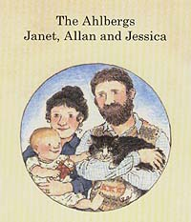  Mrs Wobble the Waitress  Mr Tick the Teacher  Etc  The Woman Who Won Things  Please Mrs Butler (Poetry)
Dick King-Smith  Roald Dahl  Michael Morpurgo | Sophie Adventure series  The Hodgeheg  The Queens Nose  The Invisible Dog  George Speaks  Aristotle  The Guard Dog  Lady LollipopThe Finger-Eater  E.S.P.  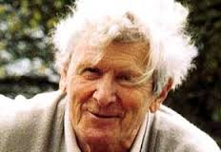  The Twits  Georges Marvellous Medicine  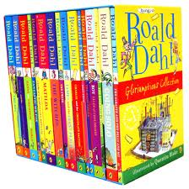  The Magic Finger  Fantastic Mr Fox  Charlie & The Chocolate Factory |  | 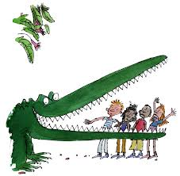
David Walliams | A Medal for Leroy  Billy the KidOut of the Ashes  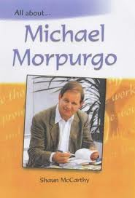  Amazing Story of Adolphus Tips  The Butterfly Lion  Shadow  Private Peaceful  Kaspar  Little Manfred  Born to Run  Running Wild  Farm Boy  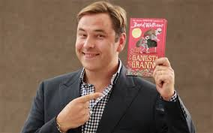  Jacqueline Wilson  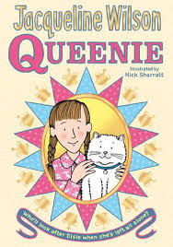  Demon Dentist  Mr Stink  Gangsta Granny  The Boy in the Dress  Diamond – Hetty Feather  Four Children and It  The Emerald Star  Queenie  Daisy and the Trouble With Burglars.

