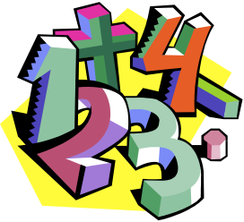

**Mathematics**

* In Maths we will solve problems involving doubling, halving and sharing.
* We will order two items by weight or capacity.
* We will use everyday language to talk about weight and capacity to compare quantities and objects and to solve problems.
* We will continue to recognise and order numbers 0-20 and solve missing number problems.

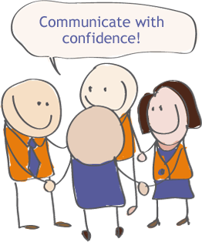 **Communication and Language**

* During this half term we will be focusing on asking and answering questions about what we have seen, heard or read.
* When speaking in circle times we will try to use past, present and future forms accurately.
* We will answer how and why questions about our experiences and in response to stories and events.
* We will develop our own narratives through our own Superhero stories, as well as discussing key events in the stories we have read.
* We will also be learning key vocabulary about Superheroes through labelling and designing our own Superhero and thinking about their unique powers.

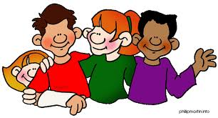 **Personal, Social & Emotional**

**Development**

* This half term we will be thinking about ‘Relationships’.
* We will talk about how ourselves and others show feelings.
* We will also talk about our own and others’ behaviour and its consequences and understand that some behaviour is unacceptable.
* When playing with our friends we will be encouraged to play cooperatively, taking in turns with others. We will take account of one another’s ideas about how to organise our activities and show sensitivity to others need and feelings.

** Literacy**

* Our focus text for this half term is ‘Eliot Jones Midnight Superhero’. We will retell the story and then innovate our own versions using story boards. Then we will write our own stories that we will read back.
* Through daily phonics sessions we will recap the Phase 3 and 4 sounds and Tricky Words. We will also be learning Phase 5 Tricky Words.
* We will continue to read and write sentences using adjacent consonants, high frequency words and two-syllable words.
* In our guided reading sessions we will demonstrate our understanding when talking to others about what we have read.

** Expressive Art & Design**

* We will design a Superhero cape and super power logo.
* We will be using simple hand sewing techniques and learning basic stitches like straight stitch, blanket stitch and cross stitch to make our own Superhero capes
* We will be using junk modelling to create our own 3D models
* We will use recycled materials to further develop our fine motor skills to create a tin can lantern.

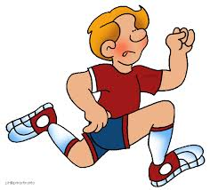 **Physical Development**

* In PE we will practice pushing, patting, throwing, catching and kicking balls and beanbags. We will negotiate space successfully, adjusting speed or direction to avoid obstacles. We will practice showing control and coordination in large and small movements.
* In handwriting we will practice using a pencil effectively with the aim to correctly form letters, using anti-clockwise movement and retracing vertical lines.
* We will become increasingly independent in self-care through dressing for PE and using the toilet independently.

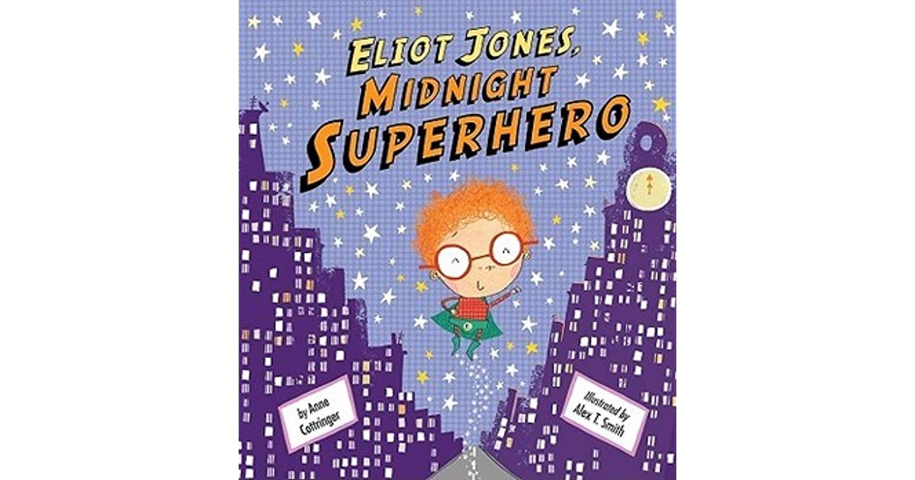

**Bampton’s Superheroes!**

**Hedgehog**

**Summer 1 2019**

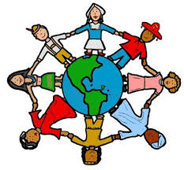 **Understanding the World**

* We will be exploring Bampton to find Bampton’s Superheroes, the ‘People who Help Us’
* We are hoping some of these Superheroes will come and visit us for the children to ask questions and find out more about their jobs
* We will keep our ‘Bampton’ working wall updated with information we find out about the town over the next half term
* We will make observations of ourselves and learn how to keep ourselves healthy and safe
* In RE we will be thinking about the ‘Israelites’ and explore different key stories about Abraham, Jacob and Joseph from the Bible.