**BAMPTON C of E PRIMARY SCHOOL**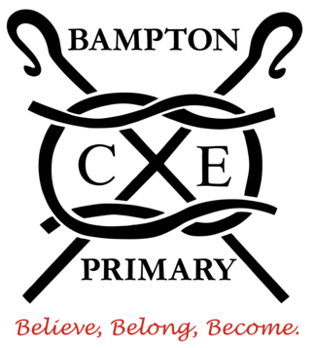



Dear parents and carers,

I hope that you enjoyed the half term break and that the children are feeling refreshed and ready to continue their learning in Hedgehog Class.

Our key question this half-term is ‘**Why do people celebrate around the world?**’ which we will explore across our curriculum by looking at different celebrations and festivals around the world, including art, music and food used in these celebrations. We will be preparing for our EYFS and KS1 nativity over the next six weeks and look forward to performing in the church towards the end of term. Further details regarding the nativity production will follow shortly.

For further information on our curriculum this year please look at the Hedgehog class page on the school website.

The rest of this letter provides you with some information that you will find useful for the term ahead.

**Routines:**

Please ensure that your child checks that they have the following each day:

* A **water bottle** that can be filled up from the classroom tap.
* Their **reading book** and **reading diary**
* There is no need to bring in a rucksack or large bag into school as we do not have space in the cloakroom area. Please continue to bring your child’s book bag which we will keep in a box in the classroom.
* Please could your child bring a **waterproof coat** into school every day.
* Your child should be wearing the correct uniform as specified in the uniform policy on the school website.

**PE days**

We will have our PE lesson on **Monday** and **Friday**. The children will need to come to school dressed appropriately without having the need of a separate PE kit bag left in school.

Devon County Council requires that jewellery, including earrings and studs, be removed for P.E. and related activities for health and safety reasons.

**Home Learning**

Children in Reception will receive handwriting homework each week to help reinforce what is being taught in school. The children will also take home a sound blending book, linked to our phonics scheme, ‘Read, Write, Inc.’ Please take time to look at this with your child. Using the phrase ‘Fred talk, read the word’, should help your child read the words in the book. Please record in your child’s reading diary when they have read and note any sounds or words they had difficulty with.

**Snack**

Reception children are provided with a healthy snack daily just before break time as this is funded by the government for all children in KS1 and Reception.

As always, we believe in an ‘open door policy’, so please feel free to come into the classroom in the morning as the children settle into their morning task.

Please do not hesitate to contact us if you have any concerns or questions.

Many thanks,

Mr. McCutcheon

Hedgehog Class