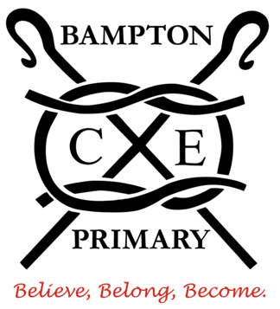
BAMPTON C of E PRIMARY SCHOOL
Dear parents and carers,

I hope you had a lovely half term and are energised for the term ahead.
You can now find the curriculum overview for this academic year on the school website: https://bamptonschool.org/curriculumoverview/

This term, our class topic is Traditional Tales. We will be learning traditional stories and putting our own twist on them. We will also be reacting the stories, as well as cooking / baking lots of food from the stories.

Routines:
Please ensure that your child checks that they have the following each day:
- Water bottle
- Reading book and reading diary
- Waterproof coat
- Hat and gloves if cold
- Milk and fruit will be issued daily

Uniform
- Your child should be wearing the correct uniform as specified in the uniform policy on the school website. This is:
  - Black shorts/trousers/skirt
  - White polo shirt
  - Red logo jumper/cardigan
  - Black shoes

We have plenty of second-hand uniform in school. Please ask if you would like some in exchange for a small donation – we would love to free up the space and have the uniform be used!

PE
This term we will have PE on Thursday and a Friday. The children will need to come to school dressed in their PE kits on these days. PE kit is:
- Red logo T-shirt
- Black shorts/joggers/leggings
- Black trainers
- Red/black logo jumper. (We are phasing out the black PE jumpers.)

Please also note that Devon County Council requires that jewellery, including earrings and studs, be removed for PE and related activities for health and safety reasons.

Daily Reading
Your child should have at least one book in their bookbag that they can read as well as a book for you to share with your child. Please record any reading in the reading diaries.

I have an open door policy, so please feel free to come into the classroom in the morning as the children settle into their morning task.

Please do not hesitate to contact me if you have any concerns or questions.

Many thanks,

Mr. McCutcheon
Hedgehog Class Teacher

