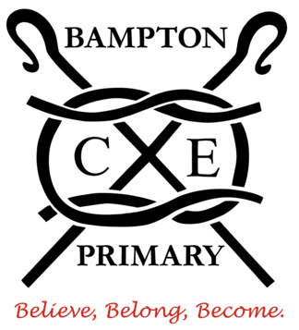
BAMPTON C of E PRIMARY SCHOOL

Dear parents and carers,

Welcome back! I hope that you enjoyed the Easter holidays and your children are rested and ready for another term.

Our key question this half-term is, ‘Why are we here and what is our purpose?’ which we will explore across our curriculum, particularly in RE and PSHE. In RE we will look at humanist reasons for existence and how they believe we should behave and we will compare this with what we have already learnt this year when studying Christianity, Hinduism and Judaism. In History we will start a culture comparison between Benin and the Anglo-Saxons where we will explore similarities and differences between these two very different ancient civilisations. Our Year 6’s will also be making their final preparations over the next few weeks for their SATs which begin on the 12th of May.

Routines:
Please ensure that your child checks that they have the following each day:
- A water bottle that can be filled up from the classroom tap.
- Their reading book.
- There is no need to bring in a rucksack or large bag into school as we do not have space in the cloakroom area. It is however very important that they bring in their Chromebook each day and that it is fully charged and ready to be used to support their learning.
- Please could your child bring a waterproof coat into school every day.
- Your child should be wearing the correct uniform as specified in the uniform policy on the school website.

PE days:
We will have our PE lessons on Wednesday and Thursday. The children will need to come to school dressed appropriately without having the need of a separate PE kit bag left in school.
Devon County Council requires that jewellery, including earrings and studs, be removed for P.E. and related activities for health and safety reasons.

Home Learning:
Home learning is an important part of your child’s education. The home learning set will be planned to reinforce the work being covered in class. Each week home learning activities are set on a Friday. They will be set a variety of different tasks, all of which will be set and fully explained on Google Classroom.

Year 5 and 6 Spellings:
A list of spellings are given out every week based on the national curriculum or particular spelling strategies being learnt in class that week. I then test the children on these spellings the following Friday. We will be regularly learning, practising and testing these words so that they become completely internalised by the child. Children should be able to apply their spellings to their own written work and not just in an isolated test.

Times Tables:
Children should learn their tables as often as possible, working towards the goal of being able to recall their times tables up to 12. Every child in Stags class has been registered onto Times Tables Rock Stars and will be given a login and password so that they can practise their times tables at home.

Daily Reading:
In years 5 and 6 children are strongly encouraged to read for at least 20 minutes each day. We will help and support children to find books that are at their appropriate level and that they find enjoyable, engaging and suitably challenging. Reading regularly, out loud to an adult where possible, is possibly the most beneficial practice that will support all areas of your child’s learning. If you are struggling to find any suitable books for your child then please do speak to me and I will be happy to help. Please also encourage your child to be persistent when trying a new book as it often takes a number of pages before the engagement and enjoyment really kicks in!

Snacks:
Stag Class are allowed to bring in a snack to eat at break time each day. Please be aware that this needs to be a healthy snack - crisps and chocolate bars are NOT appropriate. Also, please remind your children that they should not be sharing their food with others.

Please do not hesitate to contact me if you have any concerns or questions.
Many thanks,

Mark Narramore,
Stags Class Teacher

